technical report
Grocery Demand Planning and Forecasting
End-to-end Python analysis: data preparation, demand patterns, promotion effectiveness, forecasting and replenishment
By Uloh C. Armstrong
Organisation Basketline Supermarkets (fictional)
Tool Python (Jupyter notebook)
Data Synthetic daily sales, 8 stores x 13 product families, 2023-2025
Analysis file notebooks/basketline_demand_planning_analysis.ipynb
Date 7 November 2026

Basketline Supermarkets is a fictional company and the dataset is synthetic, created for analytical practice and portfolio demonstration. No record represents a real retailer, store, customer or transaction, and no finding in this report is evidence about real grocery markets.

1. Project overview
Item | Detail
Project title | Grocery Demand Planning: Forecasting Store Sales and Rethinking Safety Stock
Business scenario | Basketline Supermarkets (fictional) runs 8 grocery stores in 5 Nigerian cities and 3 formats. Demand has been inconsistent, making it hard to plan sales, understand promotions and prepare for demand swings.
Business problem | Planning relies on rules of thumb, including two days of safety stock for every product family in every store. There is no quantified view of demand patterns, real promotion effects or forecastability, so stock is wrong in both directions.
Purpose | Turn three years of daily sales into an evidence base for demand planning: patterns, promotion effects, an evaluated forecast and a replenishment policy.
Scope | Daily sales for 103 store x product-family series, 1 Jan 2023 - 31 Dec 2025; Q1 2026 forecast; store-family replenishment policy. SKU detail, costs and inventory positions are out of scope (not in the data).
Tool | Python in a Jupyter notebook: pandas, NumPy, SciPy, statsmodels, scikit-learn, Matplotlib. No other tool was needed.
Intended users | Head of merchandise planning, purchasing and replenishment, store operations, promotions / trade marketing.

Basketline Supermarkets is a fictional company and the dataset is synthetic, created for analytical practice and portfolio demonstration. No record represents a real retailer, store, customer or transaction, and no finding in this report is evidence about real grocery markets.

2. Business objectives and analytical questions
Objective | Questions | Analytical requirement
1. Analyse historical sales across stores | Which categories generate the highest volume? Which stores have the highest sales? | Yearly KPIs, category and family shares (units and naira), store ranking on totals, per trading day and per sqm, like-for-like trend
2. Seasonal patterns and fluctuations | How does demand vary across days, weeks and months? Which families are seasonal? Which are volatile or stable? | Weekday and payday indices with Kruskal-Wallis / Mann-Whitney tests; monthly seasonal index; STL and seasonal strength; festive event studies; volatility (CV) around expected demand
3. Promotions vs sales | Promo vs non-promo volumes; families with the largest increases; consistency across outlets; promotions with lower sales | Naive comparison; per-family log-linear model; event-level uplift vs modelled baseline; Kruskal-Wallis across stores; rule-based diagnosis
4. Stores and categories | How does demand differ by store, format and category? What did store events do? | Mix index, format KPIs, before/after comparisons relative to other stores
5. Forecasting model | Can history forecast sales? Which families are most predictable? How accurate are different methods? Which stores need attention? | Rolling-origin back-test of 6 methods; WAPE, bias, weekly WAPE; Wilcoxon test; permutation importance; Q1 2026 forecast; composite store attention score
6. Planning recommendations | How can forecasts improve purchasing and replenishment? | Safety stock from cumulative forecast error over lead time + review period; order-up-to levels; comparison with the 2-day rule and with a naive forecast

3. Dataset overview
The source is one Excel workbook, data/raw/basketline_grocery_demand_data.xlsx, with 12 sheets. It was loaded with pd.read_excel(sheet_name=None) in about 10 seconds.
Sheet | Rows | Content | Role in project
raw_sales_daily | 104,833 | POS feed: load time, date, store, family, units, value, promotion flag and code, stock-out | Primary source
sales_daily | 104,118 | Provider's cleaned version | Reconciliation only
stores | 8 | City, region, format, sqm, opening date | Store analysis, features
product_families | 13 | Category, storage, shelf life | Category analysis, shelf-life check
promotions | 135 | Type, discount, dates; 127 completed, 8 planned (Q1 2026) | Promotion analysis, future inputs
promotion_stores | 817 | Store participation | Promotion calendar
calendar | 1,186 | Daily to 31 Mar 2026: holidays, Ramadan, payday, school, season, closures | Seasonality, features
store_events | 10 | Opening, refurbishment, competitor, POS outages | Explaining gaps and shifts
replenishment_params | 103 | Lead time, review period, case pack, shelf life, 2-day safety stock, 97% target | Replenishment policy

Key fields:
- the key sale_date x store_id x family_id;
- units_sold and sales_value_ngn;
- the promotion flag and code;
- the stock-out flag.
Dataset limitations:
- family-level rather than SKU-level data;
- no inventory positions, costs or margins;
- stock-out days record sales, not demand;
- one store has only 15 months of history;
- the data is synthetic.

4. Data quality assessment
Dimension | Finding in the raw feed | Risk if ignored
Validity / format | 6,344 dates stored as text DD/MM/YYYY (6.1%) | Rows dropped or mis-sorted in time series
Consistency | 4,231 store codes and 5,203 family labels off-standard (case, hyphens, store names, legacy names); 7,520 promotion flags in 9 formats | Sales split across phantom stores and families
Uniqueness | 520 exact duplicates; 156 date-store-family keys loaded twice with different values | Double counting
Referential integrity | 39 rows for store S99, not in the store master (a test till) | Non-trading sales in totals
Accuracy | 22 negative unit values with positive sales value; unit values about 100x normal in 363 rows (one store-month in kobo) | Wrong totals and prices
Completeness | 261 missing units, 628 missing values, 491 promotion rows without a code; 8,770 store-family-days absent (closures, outages, pre-opening) | Gaps treated as zero demand
Measurement | 1.6% of rows flagged stock-out (sales understate demand); rare very large B2B orders | Biased demand and volatility estimates

All reference tables passed key, foreign-key and calendar-continuity checks.

5. Data cleaning and preparation
Issue | Variable | Action | Rows
Dates stored as text DD/MM/YYYY | sale_date | Parsed day-first to a true date | 6,344
Store code variants | store_code | Standardised to S01-S08 | 4,192
Rows for store S99 (not in store master; 3 days, 1-5 units per row) | store_code | Excluded | 39
Product family label variants | product_family | Mapped to the 13 master families (audited mapping table) | 5,203
Exact duplicate rows | all | Removed | 520
Same date-store-family loaded twice with different values | units_sold, sales_value | Kept the most recent load_timestamp | 156
Negative units_sold with positive sales_value | units_sold | Sign corrected (absolute value) | 22
Sales values ~100x too large for one store-month (recorded in kobo) | sales_value | Divided by 100 for the whole affected store-month | 401
Missing units_sold (value present) | units_sold | Imputed = value / local unit price | 260
Missing sales_value (units present) | sales_value | Imputed = units x local unit price | 624
Promotion flag variants (Y/N/Yes/No/1/0/TRUE/FALSE/blank) | promo_flag | Mapped to 0/1 (blank = 0) | 7,520
Promotion rows missing promo_code | promo_code | Filled from promotion calendar (store, family, date) | 489

Result. 104,833 raw rows became 104,118 clean rows. The 715 rows removed were all non-sales:
- 520 exact duplicates;
- 156 superseded loads;
- 39 test-till rows.
The cleaned table was reconciled independently with the provider's sales_daily. Keys, units, values, promotion flags and stock-out flags matched on 100% of rows.

Transformations and derived variables
- Complete panel: 103 series x 1,096 days with a day_status for every missing day. There are 8,112 pre-opening, 296 Christmas closure, 273 refurbishment and 89 POS-outage rows, and no unexplained gaps. Missing days are not treated as zero demand.
- Calendar and festival features: weekday, payday window, public holidays, Ramadan, back-to-school; days to Christmas, Easter (Good Friday) and Eid; December, January, Easter and Eid windows.
- Promotion features: type, headline discount, promotion day number, days since the last promotion ended, 14-day post-promotion window.
- Bulk-order flag (two tiers): more than 4x the centred 29-day median outside festive windows and promotions, or more than 8x on any day. It flagged 52 days (0.9% of units): all 45 days in the provider's flag plus 7 extreme days, 6 inside festive windows.
- Adjusted units (units_adj): bulk days are replaced by the local median for modelling. Reported totals always use actual units.
- Modelling exclusions: stock-out and bulk days are excluded from model training and accuracy scoring because they do not represent shelf demand. They are not deleted from the data.
Output: data/processed/basketline_sales_daily_clean.csv (16 columns, one row per trading day x store x family), the cleaning log and the family-label mapping.

6. Tool-specific execution (Python)
The notebook notebooks/basketline_demand_planning_analysis.ipynb has 105 cells (36 code cells). It runs from start to finish in about 3 minutes, uses relative paths and a fixed seed (42), and writes all outputs. The table below lists each major step.
Step | What and why | Python method | Output | Objective
Ingestion | Loaded all sheets, inventoried shapes, checked required sheets | pd.read_excel(sheet_name=None), assertions | Sheet inventory; raw and reference frames | Data assessment
Quality profiling | Counted each suspected issue before changing anything | Boolean masks, isin, duplicated, group-wise medians (groupby().transform('median')) | Quality table (12 checks) | Data assessment
Label standardisation | Mapped 50+ raw family labels to 13 masters | Regex normalisation, exact / alias / difflib.get_close_matches fuzzy mapping with an audit table | family_label_mapping.csv | Cleaning
De-duplication | Removed re-uploads, kept latest load per key | duplicated(subset=..., keep='last') after sorting on load time | -676 rows | Cleaning
Unit-of-measure fix | Found and rescaled the kobo store-month | Ratio to family-day median; store-month share > 50% rule | 401 rows rescaled | Cleaning
Imputation | Filled missing units or values | Centred 15-day rolling median unit price per series (rolling(center=True)) | 884 rows imputed, flagged | Cleaning
Promotion linkage | Filled missing codes; verified flags | Expanded promotion calendar (pd.date_range per promotion-store), left merge | 0 flag-calendar mismatches | Cleaning, Obj. 3
Reconciliation | Compared with provider's table | Outer merge with indicator; equality rates | 100% match | Validation
Daily panel | Full grid with day status | Cross join, np.where status rules from calendar and events, assertion of no unexplained gaps | 112,888-row panel | Obj. 2, 5
Feature engineering | Festival distance, windows, promotion state | np.searchsorted on anchor dates; grouped forward-fill for days since promotion | Feature columns | Obj. 2, 3, 5
Bulk detection | Separated B2B orders from shelf demand | Centred 29-day rolling median per series; two-tier rule; crosstab vs provider | 52 bulk days; units_adj | Obj. 2, 5
Descriptive KPIs | Year, category, family, store and like-for-like tables | groupby().agg, ranks, per-day and per-sqm normalisation | Charts 01-03 | Obj. 1, 4
Calendar effects | Weekday and payday indices | Store-day / centred 28-day mean; scipy.stats.kruskal, mannwhitneyu | Chart 04, index tables | Obj. 2
Seasonality | Monthly index, decomposition, event studies | Pivot heatmap; statsmodels STL(period=52, robust=True); seasonal strength; aligned event windows | Charts 05-07 | Obj. 2
Volatility | CV around expected pattern on ordinary days | Ratio to rolling level x weekday factor; classification | Chart 08; volatility_by_series.csv | Obj. 2, 5
Promotion model | Uplift and post-promotion effect per family | smf.ols log-linear models, full-rank design checked, store-week clustered SE | Chart 09; coefficient tables | Obj. 3
Event uplift | Actual vs no-promotion baseline per promotion-store | Model prediction with promotion switched off + Duan smearing; pre-period and price checks | promotion_event_results.csv; charts 10-11 | Obj. 3
Store events | Competitor, refurbishment, new-store ramp | Ratio-of-ratios vs like-for-like stores; rolling weekly series | Chart 12 | Obj. 4
Forecast back-test | 6 methods, 7 origins x 28 days | Leak-free lag features (28 / 91 days, last year); HistGradientBoostingRegressor(loss='poisson'); ExponentialSmoothing per series; naive rules | backtest_predictions.csv.gz | Obj. 5
Evaluation | Accuracy, bias, significance, drivers | WAPE, bias, weekly WAPE; scipy.stats.wilcoxon; permutation_importance | Charts 13-15 | Obj. 5
Forward forecast | Q1 2026 with planned promotions | Refit on all history; empirical p10/p90 from back-test ratios | forecast_q1_2026.csv; chart 16 | Obj. 5, 6
Replenishment | Safety stock and order-up-to | Cumulative back-test error over P = L + R via np.convolve; z = 1.88; case-pack rounding | replenishment_policy_by_series.csv; chart 17 | Obj. 6
QA | 12 automated checks | Assertions on counts, totals, leakage, coverage | key_metrics.json | Validation

Key design decisions
- Units, not naira: prices rose about 35% a year, so naira growth would hide flat demand. Every demand analysis and forecast uses units.
- Normalised indices: weekday and payday effects are measured relative to each store's own 28-day centred average. This removes store size, trend and season.
- Full-rank promotion model: the first version produced unstable standard errors because of perfectly collinear dummies (format x weekday with store effects, December windows with the month effect, new-store ramp weeks with the store effect). The design was recoded to full rank, verified by assertion, and gave stable 95% confidence intervals.
- Leakage control: in the forecast, each feature is at least as old as the forecast horizon. Future promotions come from the published calendar, which is legitimately known in advance.
- Empirical safety-stock error: sigma is measured from the back-test as the spread of cumulative error over each series' protection period, rather than assuming independent daily errors.

7. Objective-by-objective analysis

Objective 1 - Historical sales
- Units: 11.15m in 2023, 10.87m in 2024 (-2.5%) and 11.44m in 2025 (+5.3%, helped by the new store).
- Naira sales: ₦16.24bn, ₦21.53bn and ₦30.4bn. The average price rose from ₦1,457 to ₦2,657.
- Like-for-like (2025 vs 2023): units -2.3%, naira +79.7%.
- Categories by units: Fresh Food 29.1%, Pantry Staples 27.9%, Beverages 22.0%.
- Categories by naira: Pantry Staples 40.4%, Fresh Food 35.0%.
- Highest-volume families: soft drinks (17%), noodles (14%), snacks (12%).
- Value leader: rice and grains, 14.1% of naira sales from 3.4% of units.
- Stores: S02 Ikeja has the highest sales (₦12.3m per trading day), followed by S01 Lekki (₦11.8m). Per square metre, S08 Ajah Express leads (₦4,782 per sqm per day) and the hypermarkets are lowest.
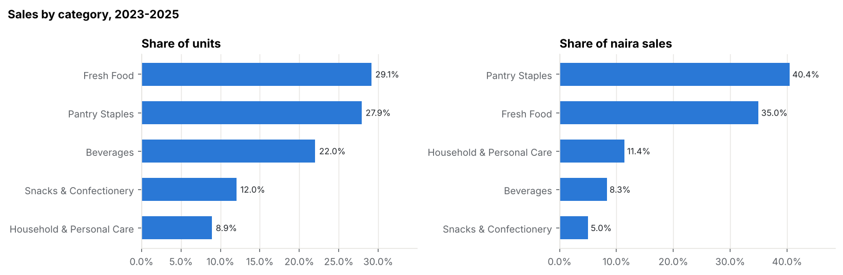
Figure 1. Category shares of units and naira sales.
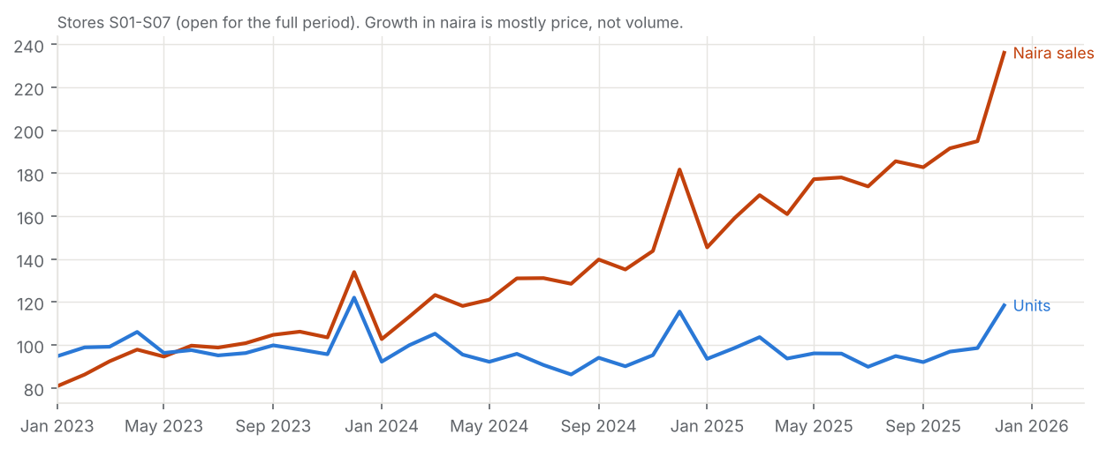
Figure 2. Like-for-like naira sales vs units (2023 = 100).

Objective 2 - Seasonality and fluctuations
- Weekday:
  - hypermarkets: Saturday 1.42, Tuesday 0.81;
  - supermarkets: Saturday 1.32;
  - express: Friday 1.14, Sunday 0.77.
All differences are significant (Kruskal-Wallis p < 1e-26).
- Payday: the salary window is significantly above mid-month (Mann-Whitney p < 1e-300).
  - by family: household +18%, rice +16%, personal care +14%, oils +14%, bread +4%;
  - by store: Ibadan +15%, Lekki +5%.
- Monthly: December peaks for 12 of 13 families (beer 1.48, soft drinks 1.42, frozen 1.40). Breakfast and hot beverages peaks in September. Soft drinks are high in March and low in the rainy season. January is below average for most families.
- Seasonal families (monthly peak-to-trough):
  - strong: beer, soft drinks, frozen, fresh produce;
  - moderate: rice, oils, snacks, personal care, household, breakfast;
  - weak: dairy, bread, noodles.
Chain weekly STL seasonal strength is 0.91.
- Festivals:
  - Christmas week: frozen 2.7x, beer 2.3x, soft drinks 2.3x, rice 2.1x;
  - Eid al-Fitr: 1.6x in Kano vs 1.1-1.2x elsewhere;
  - Ramadan: +13% in Kano.
- Volatility: 58 series are stable, 41 moderate and 4 volatile (Port Harcourt fresh produce, frozen and beer; Ajah fresh produce). Bread is the most stable family (CV 0.17) and fresh produce the least (0.37). Port Harcourt (0.33) and Ajah Express (0.29) are the noisiest stores.
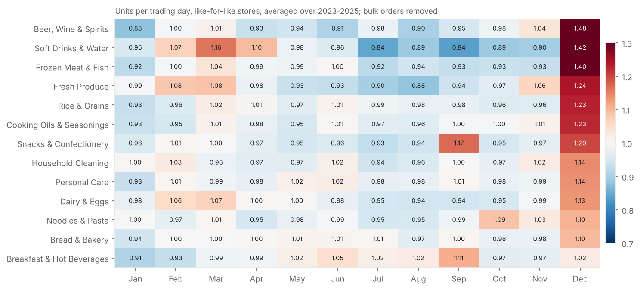
Figure 3. Monthly seasonal index by family.
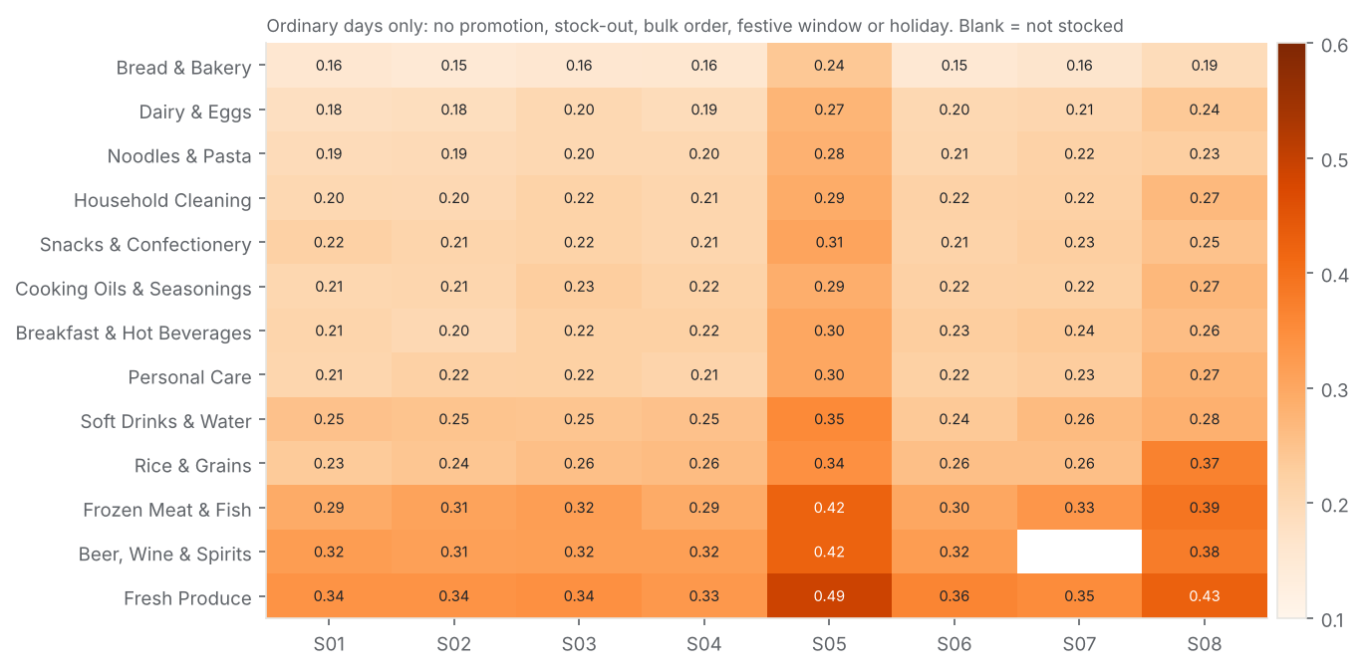
Figure 4. Baseline volatility by store and family.

Objective 3 - Promotions
- Naive comparison: promotion-day averages are 9-41% higher. Promotions cluster in January, March and September-November, so this comparison is confounded.
- Controlled uplift (per-family regression, R-squared 0.51-0.79):
  - highest: household +40%, noodles +33%, beer +30%, soft drinks and snacks +27%;
  - lowest: fresh produce +9%, bread +8%;
  - all significant at p < 0.001.
- Post-promotion dip: storables dip in the 14 days after a promotion (household -7%, noodles -6%, beer and soft drinks -5%). There is no measurable dip for perishables.
- Event level (768 promotion-store events):
  - median uplift 1.17;
  - by mechanic: multibuy 1.36, price discount 1.16, display-only 1.14;
  - discount depth is only weakly related to uplift (Spearman 0.14);
  - the achieved average price fall is 8.8% against a median headline of 20%.
- Across outlets: results differ significantly (Kruskal-Wallis p = 3e-13). Ibadan has a median uplift of 1.28, Lekki and Ajah 1.11. Within the same chain-wide promotion, store uplifts typically differ by 0.40.
- Lower sales: 113 events (15%) coincided with lower sales:
  - seasonal timing: 33 (e.g. January after December);
  - stock-outs: 8 (e.g. Ramadan Staples Saver - Rice 2024 at Wuse, with stock-outs on 86% of days);
  - shelf price not reduced: 4 events (PR24-022 and PR25-043 at S05 and S07);
  - weak response: the remainder.
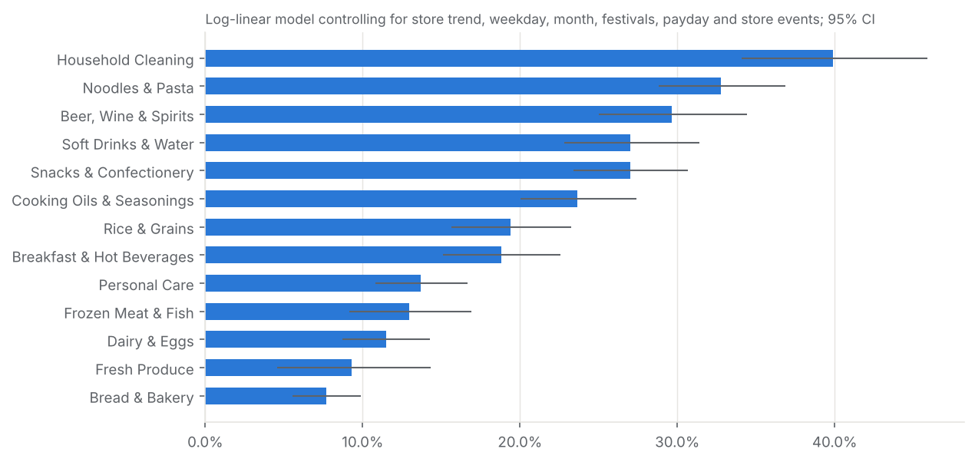
Figure 5. Controlled promotion uplift by family (95% CI).
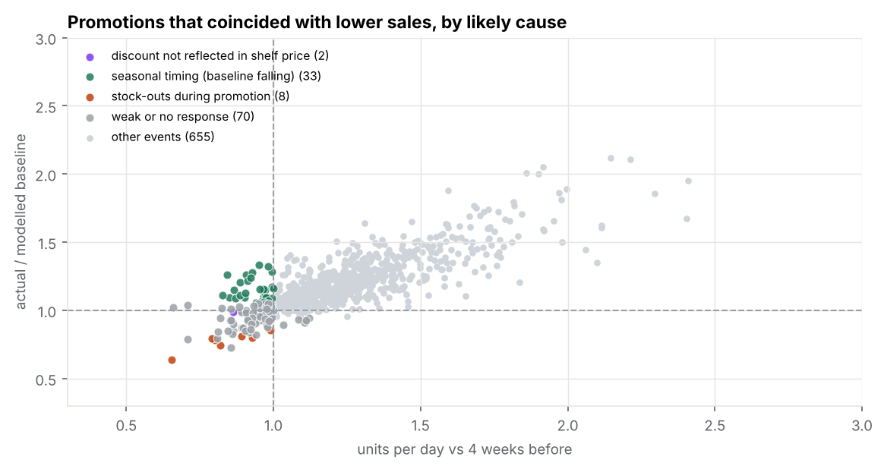
Figure 6. Promotions that coincided with lower sales, by diagnosed cause.

Objective 4 - Stores and categories
- Mix by store:
  - Lekki over-indexes on beer (1.30), personal care and dairy, and under-indexes on noodles (0.70);
  - Kano: rice 1.27, oils 1.25;
  - Ajah Express: snacks 1.30, bread 1.27, rice only 0.42.
- By format: express has the highest sales per sqm and the weakest promotion response; supermarkets respond most to promotions (median 1.20).
- Store events: the competitor opening cost Wuse about 9% of volume relative to other stores. Surulere was about 14% higher after its refurbishment. Ajah Express reached 90% of steady volume in about 9 weeks.

Objective 5 - Forecasting
Method | Daily WAPE | Bias | Weekly WAPE
Gradient boosting (91-day lags) | 20.7% | -2.1% | 9.9%
Gradient boosting (28-day lags) | 20.8% | -2.6% | 10.0%
Holt-Winters ETS | 23.7% | -3.2% | 14.6%
4-week weekday average | 25.1% | -3.8% | 14.1%
Last year x level | 29.8% | -0.7% | 15.3%
Seasonal naive (last week) | 30.5% | -2.2% | 16.0%

- Can history forecast sales? Yes. The best model cuts daily error by about 17% and weekly error by about 29% compared with the 4-week weekday average, and beats it in every back-test window (WAPE 19.9-21.7%).
- 28-day vs 91-day lags: the two gradient-boosting variants are statistically indistinguishable (Wilcoxon p = 0.541). The 91-day version is selected because it can forecast the whole quarter from one origin.
- Most predictable families: bread (13%), dairy (17%), noodles, breakfast, oils (18-19%).
- Least predictable families: fresh produce (30%), beer (29%), frozen (26%).
- Largest gains over the naive method: promotion-driven families (noodles -27%, household, soft drinks and snacks about -21%).
- Hardest stores: Port Harcourt (29%) and Ajah Express (23.5%); the other stores are at 19-20%.
- Main drivers (permutation importance): family, store, recent level and weekday profile, weekday, days to Christmas, promotion type.
- Q1 2026 forecast: 2.84m units, in line with Q1 2025 (2.85m). In the back-test, 80% of chain weekly actuals fell between 0.98x and 1.061x the forecast.
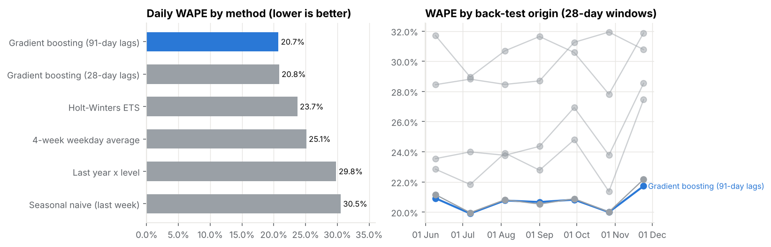
Figure 7. Back-test accuracy by method and by origin.
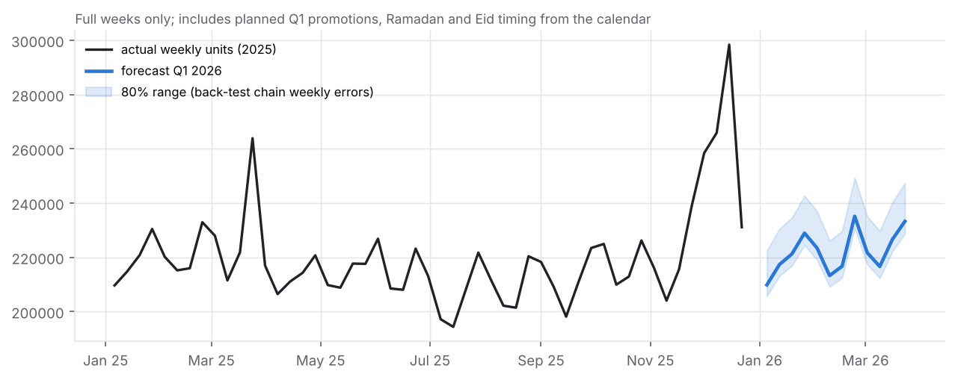
Figure 8. Q1 2026 weekly forecast with an 80% range.

Objective 6 - Replenishment
- Policy: safety stock = 1.88 x sigma_P, where sigma_P is the back-test spread of cumulative error over lead time + review period (2 to 14 days).
- Verdict on the current 2-day rule: 53 series are about right, 37 are over-stocked and 13 are under-protected.
- Where: over-stocked series are mainly bread, dairy and fresh produce, which need about 0.5-1 day. Under-protected series are mainly Port Harcourt (7 of 13) and Kano (3), which need up to 3.7 days.
- Total safety stock: 48.7k units recommended vs 60.6k today (20% lower).
- Value of the better forecast: the naive forecast would need 83.6k units for the same service level, so the selected model needs 41.8% less.
- Shelf life: no order-up-to level exceeds shelf life.
- Stock-outs: historical stock-out rates are not related to the safety-stock gap (Spearman 0.03). This points to supply failures as a separate cause.
- Stores needing attention: S05 Port Harcourt, S07 Kano and S08 Ajah Express.
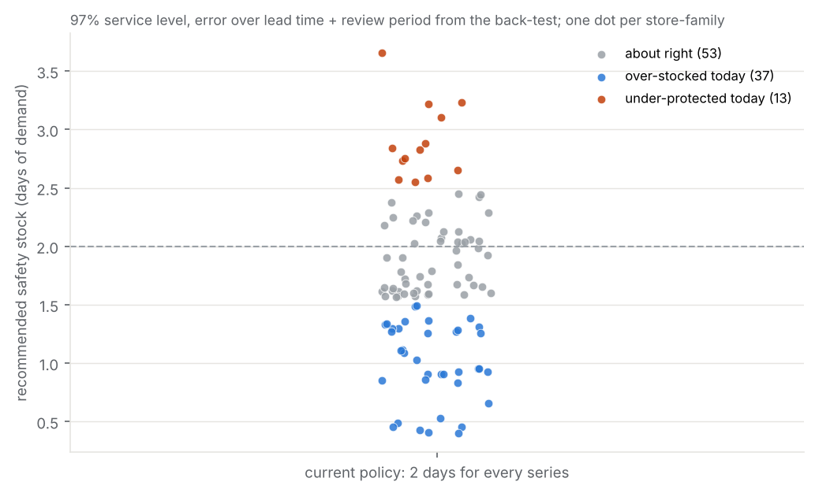
Figure 9. Recommended safety stock vs the current flat 2-day rule.

Objective completion
Objective | Procedure | Result | Status
1 Historical sales | KPIs, shares, normalised ranking, LFL trend | Volume flat, naira +80% LFL; Fresh / Pantry lead; Ikeja top, Express top per sqm | Achieved
2 Seasonality | Indices + tests, STL, event studies, CV | Strong weekday / payday / December / regional patterns; 4 volatile series | Achieved
3 Promotions | Regression, event uplift, tests, diagnosis | Uplift 8-40% by family; multibuy best; store response differs; 15% low-sales events explained | Achieved
4 Stores and categories | Mix index, format KPIs, event comparisons | Distinct store baskets; competitor -9%, refurbishment +14% | Achieved
5 Forecasting | 6-method rolling back-test, Q1 forecast | Gradient boosting best (20.7% daily, 9.9% weekly WAPE) | Achieved
6 Planning | Safety stock and order-up-to from forecast error | Series-level policy, 20% less safety stock, 13 series raised | Achieved (units, no cost data)

8. Key findings
Finding | Evidence | Interpretation | Implication
Naira growth is price, not volume | LFL units -2.3%, naira +79.7% | Purchasing power pressure; trading down is plausible but untested | Plan and target in units
Strong, format- and region-specific calendar | Sat +42% (hyper), Fri peak (express); payday +16-18% staples; Christmas up to 2.7x; Eid 1.6x Kano | Shopping missions differ by store and region | Seasonal plans by format and region
Volatility is series-specific | CV 0.15-0.49; Port Harcourt and Ajah noisiest | Fresh and protein in Port Harcourt are hard to plan | Series-level safety stock
Promotions work unevenly | Uplift +8% to +40%; multibuy 1.36 vs price cut 1.16; display 1.14 | Mechanic and category matter more than depth | Re-allocate promotion spend
Store response differs | Ibadan 1.28 vs Lekki 1.11 (p = 3e-13) | Price-sensitive catchments respond more | Store-specific promotions
Low-sales promotions are explainable | Timing 33, stock-outs 8, price not changed 4 | Evaluation method and execution matter | Baseline evaluation + launch checks
Forecastable with ML | WAPE 20.7% daily / 9.9% weekly vs 25.1% / 14.1% | Calendar, promotions and level explain most demand | Adopt for weekly ordering
Better forecasts cut safety stock | -42% vs naive forecast; 37 series over-stocked, 13 under-protected | The flat rule is wrong in both directions | Replace the 2-day rule

9. Business recommendations
Priority | Recommendation | Supporting evidence
Immediate | Replace the 2-day safety stock with the series-level policy (cut bread, dairy and fresh produce to about 0.5-1 day; raise 13 Port Harcourt / Kano series to 2.5-3.7 days) | Objective 6; replenishment_policy_by_series.csv
Immediate | Order from the Q1 2026 forecast; monitor WAPE and bias weekly; re-train monthly | Objective 5 back-test
Immediate | Promotion launch checklist: confirm shelf price on day 1 and build stock first in long-lead stores | 4 non-executed events at S05 / S07; 8 stock-out events
Next quarter | Shift promotion spend to household, noodles, drinks and snacks and to multibuy / display mechanics; drop deep discounts on bread and fresh produce; net off post-promotion dips | Regression and event uplift
Next quarter | Store-specific promotion allocation; region-specific festive and payday build-ups | Store uplift test; festive and payday indices
Longer term | Improve supply reliability and lead times for Port Harcourt (5 days) and Kano (7 days); monitor Wuse after the competitor opening | Store attention ranking; stock-out analysis
Longer term | Capture inventory positions, lost sales, SKU sales, promotion costs and execution compliance | Limitations; enables profit optimisation

10. Technical and analytical limitations
Type | Limitation
Observed | Synthetic data for a fictional business; family-level, not SKU-level; stock-out days understate demand with unknown lost sales; 15 months of history for S08; 7 POS-outage days with no sales recorded.
Methodological | Promotion effects are observational associations controlled for measured drivers. Event studies rest on three occurrences per festival, and Easter and Eid windows partly overlap in some years. The bulk-order rule is heuristic. Safety stock assumes back-test errors (about 20 windows per series) represent Q1 2026. The 80% intervals are empirical, not model-based.
Contextual | No costs, margins, inventory positions, competitor prices or supplier performance data, so recommendations are in units and service level rather than profit.
Assumptions | Bulk days are not shelf demand; the 97% service target applies to every series; lead and review times are accurate; planned Q1 promotions will run as scheduled.

11. Validation and quality assurance
- Data checks:
  - raw rows = clean rows + removed rows;
  - no duplicate keys;
  - every missing panel day explained;
  - the saved clean file reconciles to the analysis totals;
  - category and store totals reconcile to the grand total;
  - promotion events reconcile to promotion rows.
- Analysis checks:
  - every promotion-model design is full rank (asserted);
  - back-test horizons never exceed the minimum lag (no leakage);
  - predictions are complete for all methods;
  - forecast coverage is 103 series x 90 days with no negative values;
  - the replenishment table covers every series.
- Deliverable checks: the notebook was re-executed end to end with no errors; the clean CSV opens with integer types; all charts are generated by the notebook.
- Independent check: the cleaning matches the provider's cleaned table on 100% of rows.
- Issues found and fixed during the work:
  - a rank-deficient regression design that gave unstable standard errors;
  - an initial bulk rule that missed festive-window B2B orders and inflated the Kano Eid peak (2.7x, corrected to 1.6x);
  - a chart band that summed daily intervals and overstated weekly uncertainty.
- Unresolved: none blocking. The limitations in section 10 remain.

12. Lessons and professional competencies demonstrated
- Business problem-solving: objectives mapped to decisions (ordering, safety stock, promotions).
- Data preparation: a reproducible, logged and independently reconciled cleaning pipeline; time-series panel construction.
- Tool proficiency (Python): pandas transformations, SciPy tests, statsmodels regression and decomposition, scikit-learn gradient boosting and permutation importance, Matplotlib reporting.
- Statistical reasoning: controlling for confounding, checking design rank, clustered errors, non-parametric tests, reporting a non-significant difference honestly.
- Forecasting practice: rolling-origin back-testing, leakage control, baseline comparison, horizon trade-offs.
- Operations analytics: an empirical safety-stock and order-up-to policy.
- Communication: findings, implications and prioritized actions for non-technical stakeholders.
- Lesson: outlier handling can change business conclusions (the Eid peak). Robust detection should come before interpreting peaks.

13. Conclusion
The project addressed every objective and question in the brief. It showed:
- Demand: Basketline's demand is flat in volume but highly patterned by weekday, payday, season, festival, region and store.
- Promotions: they add 8-40% depending on family, mechanic and store, and most failures are operational.
- Forecasting: a gradient-boosting forecast clearly beats current practice and supports a full-quarter plan.
- Replenishment: a forecast-driven safety-stock policy can hold 20% less stock overall while protecting the series and stores most at risk. Together these give management a practical, evidence-based basis for demand planning.

